ENVIRONMENTAL SETUP

|  |  |
| --- | --- |
| **DATE** | 07 Nov 2022 |
| **TEAM ID** | PNT2022TMID10783 |
| **PROJECT NAME** | CUSTOMER CARE REGISTRY |

FLASK SETUP:

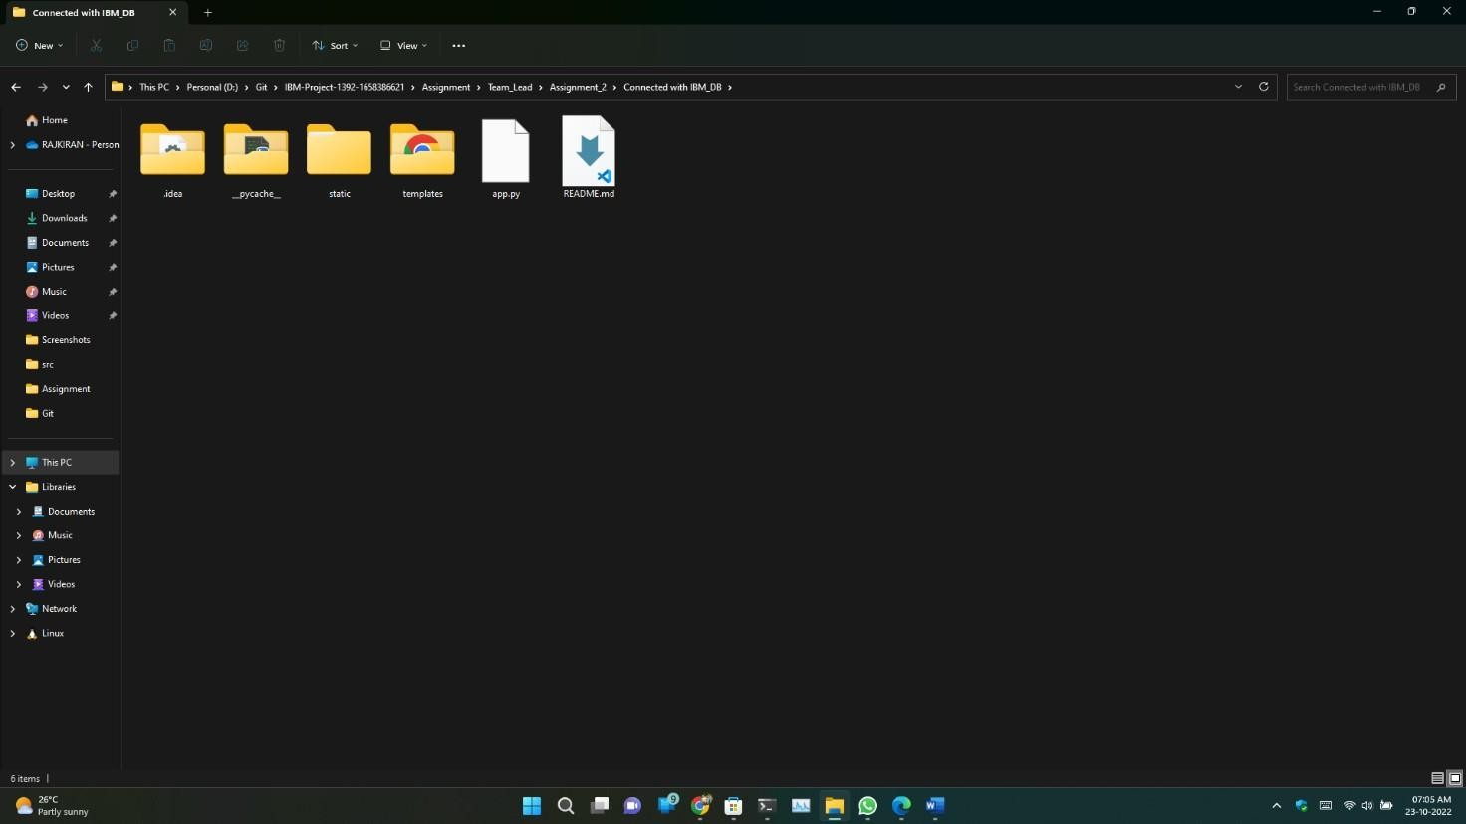

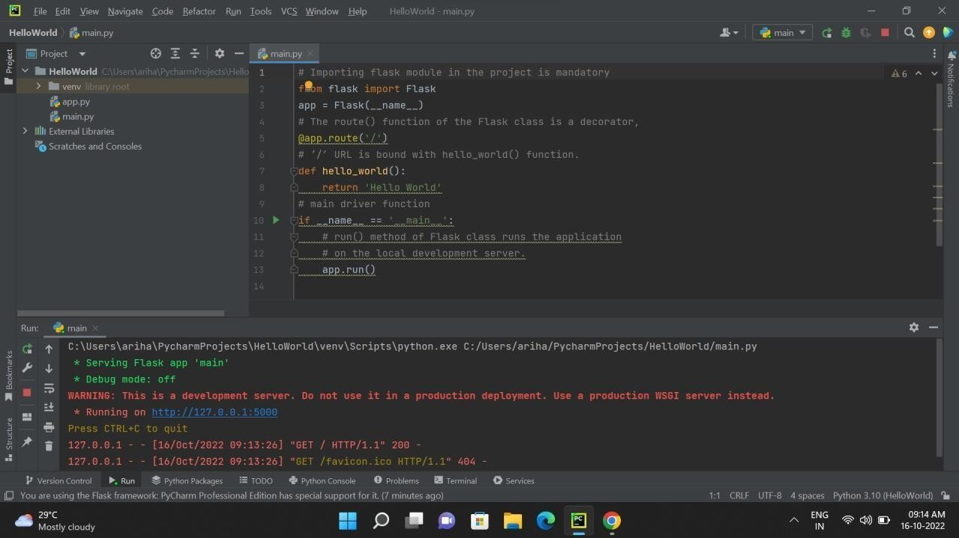

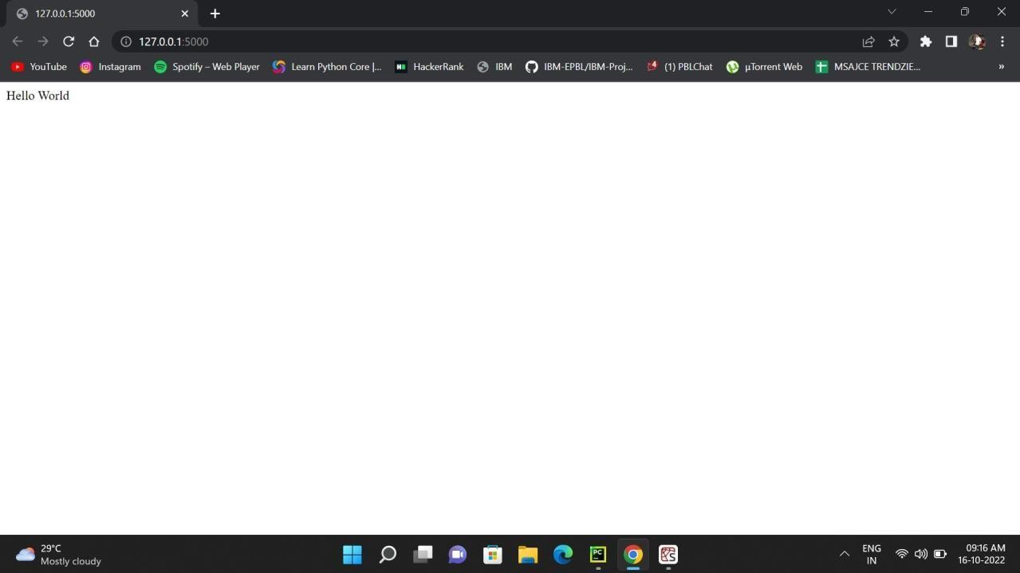

DOCKER SETUP:

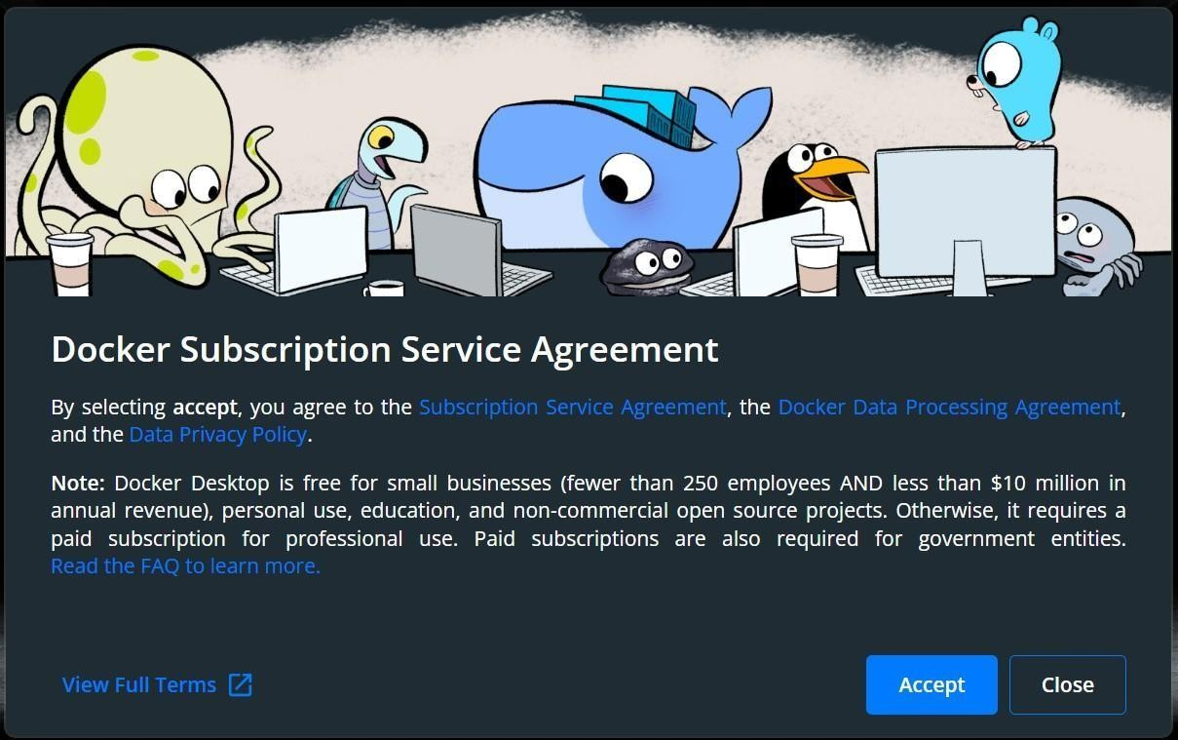

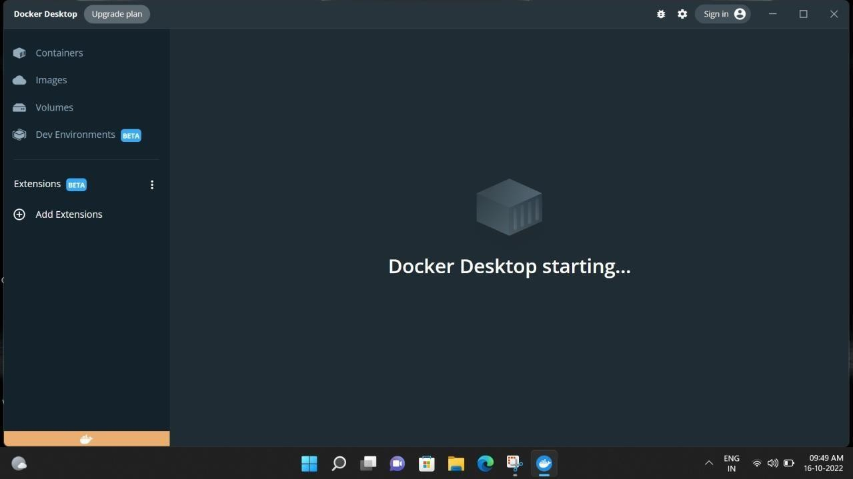

CLOUD ACCOUNT CREATION:

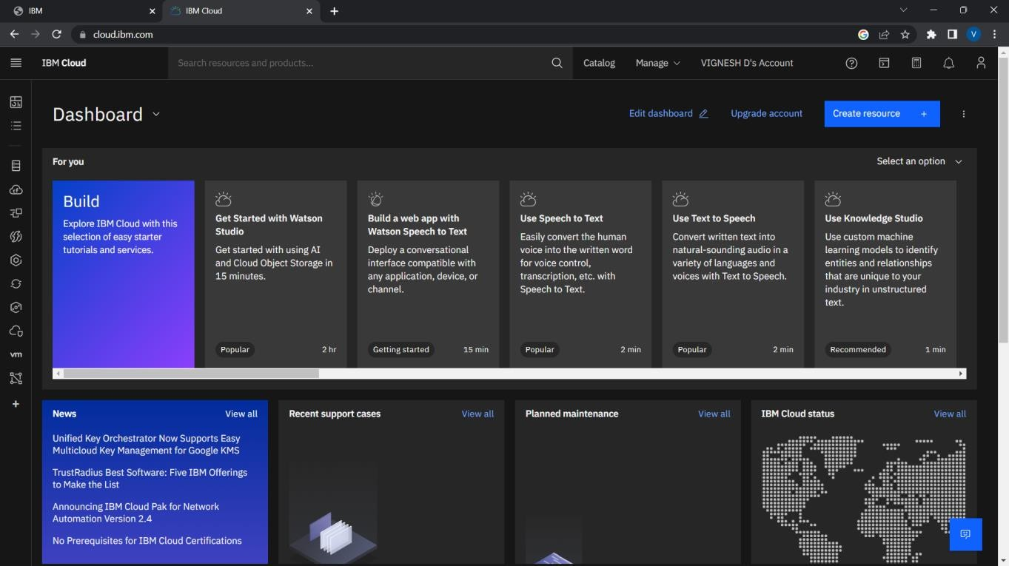

SENDGRID ACCOUNT CREATION:

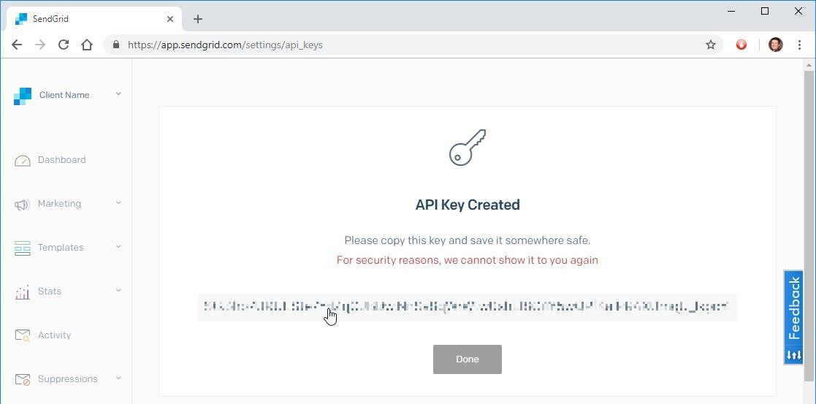

IBM CLOUD CLI INSTALL :

